• Review of manipulator

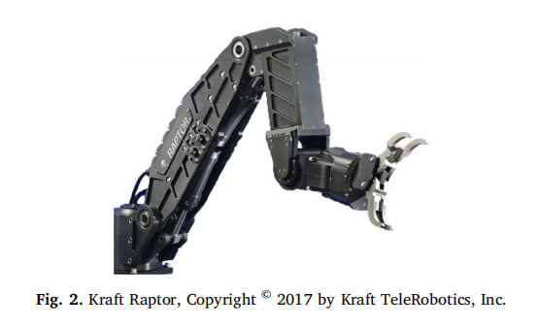

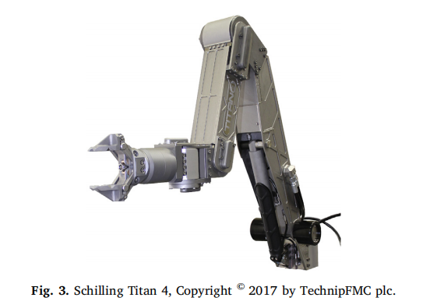

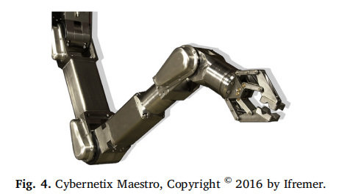

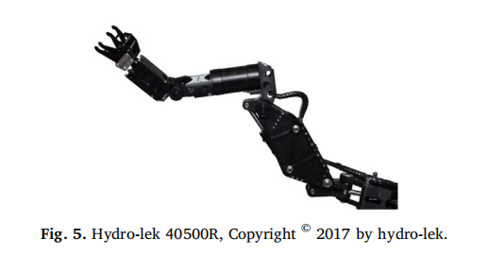

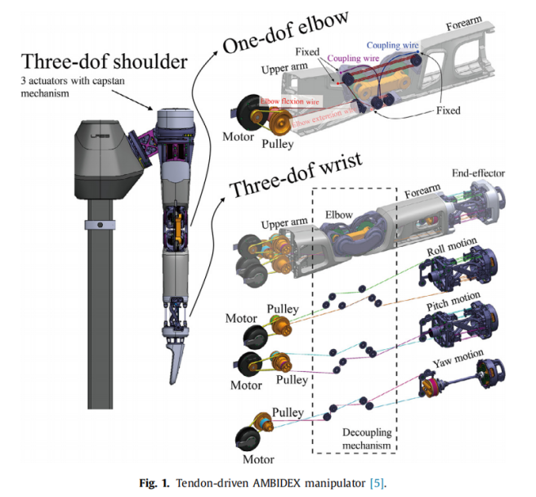

• Literature Review for tendon-driven manipulator

肌腱驱动机械臂的文献综述

Due to their lightweight and compact design, tendon-driven

robots are receiving renewed attention in the literature. By allowing for the placement of actuators and other heavy mechanical elements proximal to the base, a tendon-driven robot can be made more compact and with a considerably reduced reflected inertia, all while having less backlash compared to gear-based transmissions. For these and other reasons tendon-driven actuation is widely used in many of today’s surgical robots as well as robotic hands, gloves, and more recently, collaborative robots designed for safe physical interaction .

由于其轻巧紧凑的设计，肌腱驱动机器人在文献中重新受到关注。通过允许将致动器和其他重型机械元件放置在靠近基座的位置，肌腱驱动的机器人可以变得更紧凑，反射惯性大大减少，同时与基于齿轮的变速箱相比，具有更小的间隙。由于这些和其他原因，肌腱驱动驱动被广泛应用于今天的许多手术机器人，以及机器人手，手套，以及最近设计用于安全物理交互的协作机器人。

The main challenge with tendon-driven robots is that they are

difficult to control precisely. The tendons exhibit nonlinear and

non-repeatable elastic behavior that is dependent on factors ranging from material properties of the tendons to load, wear, and environmental conditions like temperature and humidity. The tendons typically span multiple joints, introducing additional friction

and in some cases delays and hysteresis, and their complex wiring

paths make the resulting frictional behavior particularly difficult

to model and identify. A lack of elaborate sensors [6] to measure,

e.g., the joint torque and contact force makes the identification and

control more challenging or even intractable. These and other reasons continue to limit the widespread use of tendon-driven robots,

particularly for tasks requiring accurate trajectory tracking.

肌腱驱动机器人的主要挑战在于难以精确控制。肌腱表现出非线性和不可重复的弹性行为取决于各种因素，从肌腱的材料特性到负载、磨损和环境条件(如温度和湿度)。肌腱通常跨越多个关节，引入额外的摩擦.在某些情况下，延迟和迟滞，以及它们复杂的线路路径使得产生的摩擦行为特别困难建模和识别。缺乏精密的传感器[6]来测量，例如，关节扭矩和接触力使得识别和控制更有挑战性，甚至更棘手。这些和其他原因继续限制着肌腱驱动机器人的广泛使用，特别是对于需要精确轨迹跟踪的任务。

Because of the inherent difficulty in the modeling and identification of both the rigid multibody and tendon dynamics of tendon-driven robots, data-driven model-free models, primarily those based on neural networks, have been investigated in the literature as an alternative to mechanics-based models.

由于肌腱驱动机器人的刚性多体和肌腱动力学建模和识别的固有困难，数据驱动的无模型模型，主要是基于神经网络的模型，已经在文献中作为基于力学的模型的替代研究。

The practical solution is to develop a hybrid model that takes

advantage of the generalizability and intuitive-predictive powers of

mechanics-based models with the flexibility and proven function

approximation capabilities of neural networks. The main aim of

this paper is to develop such a hybrid model for complex tendondriven robots, by merging the latest mechanics-based rigid multibody dynamic models with neural network learning-based models

for the difficult-to-capture friction and tendon modeling.

实际的解决方案是开发一个混合模型的一般化和直觉预测能力的优势基于力学的模型，具有灵活性和成熟的功能神经网络的逼近能力。的主要目的本文将最新的基于力学的刚体多体动力学模型与基于神经网络学习的模型相结合，建立复杂肌腱驱动机器人的混合模型对于难以捕捉的摩擦和肌腱建模。

调研：人工肌肉；肌腱驱动；线性；绳驱动；串联式。线性？肌腱？绳驱？（比较少）串联式？（资料多） 能不能做出来？

Rope-Driven Manipulator

Research & Review (for the Motivation)

岸电”船舶充电桩 Shore power "Marine charging pile

岸电船舶充电桩包括：交流岸电桩，直流岸电桩，交直流一体化岸电桩是通过岸电电源提供电源供给，岸电桩固定到岸边。 岸电船舶充电桩主要是给港口、公园、码头等船舶进行充电使用的一种充电装置。

Shore power Marine charging pile includes: AC shore power pile, DC shore power pile, AC-DC integrated shore power pile provides power supply through shore power supply, shore power pile fixed to the shore. Shore electric Marine charging pile is mainly a charging device used to charge ships in ports, parks and wharves.

船舶停靠港口作业期间，为了维持生产生活需要，就需要开动船上的辅助发电机发电以提供必要的动力，由此会产生大量的有害物质排放。根据统计，船舶靠港停泊期间由其辅助发电机所产生的碳排量占港口总排碳量的40%至70%，是影响港口及所在城市空气质量的重要因素。()

During port operation, in order to maintain the needs of production and living, auxiliary generators on the ship need to be operated to provide necessary power, which will result in a large amount of harmful substances emissions. According to statistics, the carbon emission generated by the auxiliary generators during the berthing period of ships accounts for 40% to 70% of the total carbon emission in the port, which is an important factor affecting the air quality of the port and the city where it is located.

所谓岸电技术，就用岸基电源替代柴油机发电，直接对邮轮、货轮、集装箱船、维修船舶等供电，以减少船舶在港口停泊时的污染排放。听上去岸电技术只是用岸上的电来替代船上的柴油发电机，但这绝不是从岸上电网拉两根电线这么简单。首先，岸电码头是高温、高湿、高腐蚀性的恶劣用电环境。其次，各个国家用电的频率不尽相同，例如美国等都采用60HZ交流电，与我国的50HZ频率不匹配。同时，各个吨位的船舶需求的电压和功率接口也不同，电压需要满足从380V到10KV的跨度，功率也存在几千伏安到十兆伏安以上的不同需求。此外，各个公司船舶对外接口不同，岸电技术要能主动检测和适应不同的接口，以满足不同公司船舶的需求。（用电环境差；人有危险，用自动化设备，改善了生产环境；Motivation，2个以上——在水中自动充电；）

The so-called shore power technology uses shore-based power sources instead of diesel engines to directly supply power to cruise ships, cargo ships, container ships, maintenance ships, etc., so as to reduce pollution emissions when ships berth at ports. It sounds like shore power is just replacing diesel generators on a ship with electricity from shore, but it's not as simple as pulling two wires from the shore grid. First of all, the shore power terminal is a bad electricity environment with high temperature, high humidity and high corrosion. Secondly, various countries use different electric frequency, such as America, etc., uses 60HZ alternating current, which does not match with our country's 50HZ frequency. At the same time, the voltage and power interface requirements of various tonnage ships are also different. The voltage needs to meet the span from 380V to 10KV, and the power also exists different needs of several thousand volt-amps to more than ten megavolt-amps. In addition, ships of different companies have different external interfaces, so shore power technology should be able to proactively detect and adapt to different interfaces to meet the needs of ships of different companies.

可以说，岸电技术是一门新兴的综合的系统解决工程，要针对不同实际情况提供不同船舶供电方法。节能减排是国家战略举措，特别针对船舶港口污染的问题，国家提出了港口转型升级的战略，显然，岸电技术是实现港口绿色减排的重要途径。

It can be said that shore power technology is a new integrated system solution project, which needs to provide different power supply methods for different actual situations. Energy conservation and emission reduction is a national strategic measure. Especially for the problem of ship port pollution, the country has put forward the strategy of port transformation and upgrading. Obviously, shore power technology is an important way to achieve green emission reduction of ports.